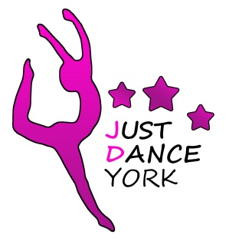
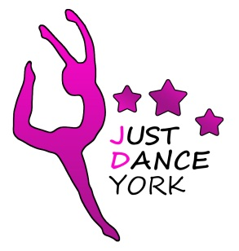

Just dance york
are enrolling new members this september!

2018

- FRIENDLY QUALFIED TEACHERS

- STREET AND FREESTYLE DANCING FOR AGES 3-18

- GIRLS CLASSES ON MONDAYS- HEWORTH HALL, MELROSEGATE

- BOYS BREAK/STREET ON THURSDAYS - EARSWICK VILLAGE HALL

- WWW.JUSTDANCEYORK.CO.UK/FACEBOOK- JUST DANCE YORK

CONTACT STACEY FOR MORE INFORMATION: justdanceyork@gmail.com


COME JOIN US AND…

